Electronic Supplementary Material (ESM) for “Extinction risk and eco-evolutionary dynamics in a variable environment with increasing frequency of extreme events”
Figures ESM1. Examples of simulations. In the first panel are reported p(E_{a}), s, , and. The histogram panels represents the distribution of trait z at t = 150 (start of climate change, t_{ch}), 200, 250, 300. The vertical dashed line is set at population mean . In the population size panel, the blue line represent average fitness multiplied by 100 for graphical purposes. Fitness declines with increasing distance between value of the quantitative trait and environmental optimum. Population size is reported after mortality (which includes base mortality, selection, mortality induced by point extreme if occurs). Vertical segments in the population size panel identify the occurrence of point extreme events. The last panel represent values of the optimum Θ. Black points and black line are values of . Red dashed line is the mean value of the distribution of Θ.The text extinct” is added in the population panel when the population went extinct. A clear phenotypic lag is observed the = 2 10⁻².
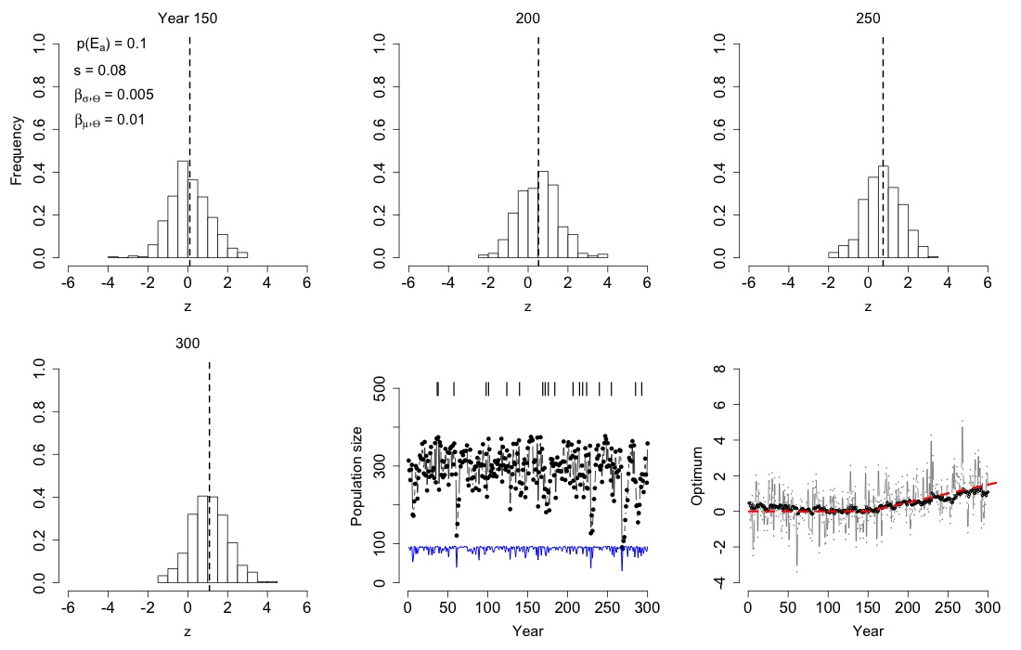
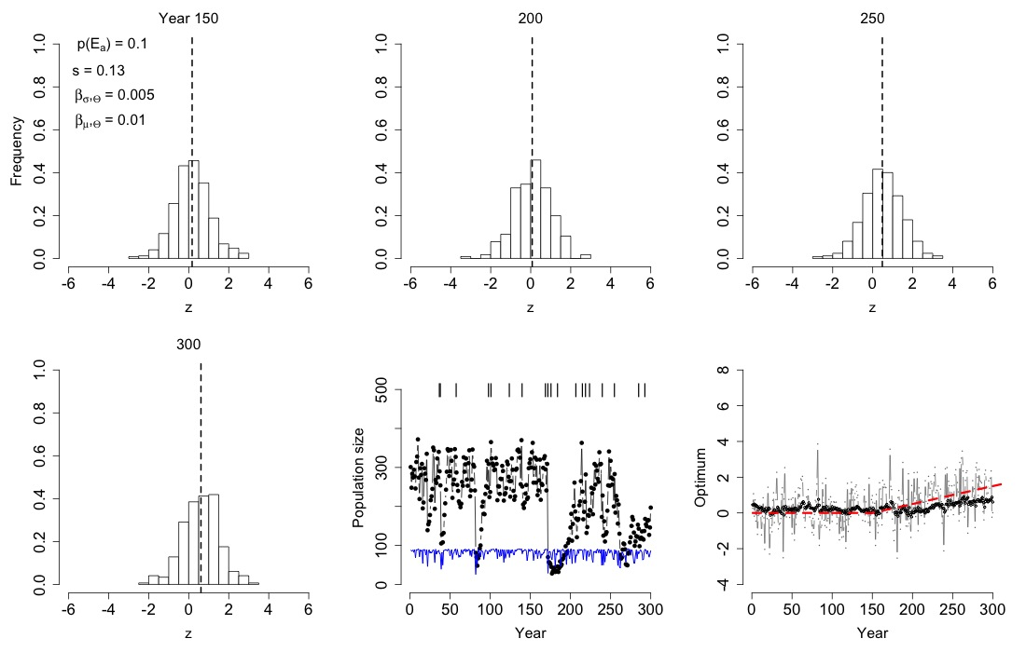
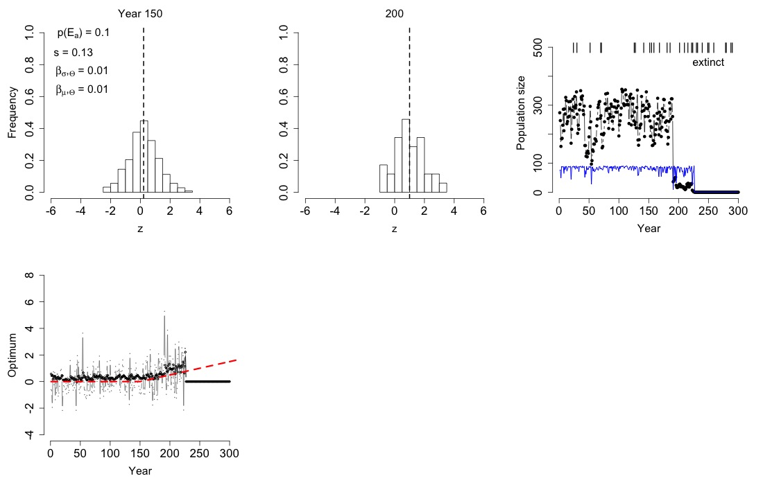
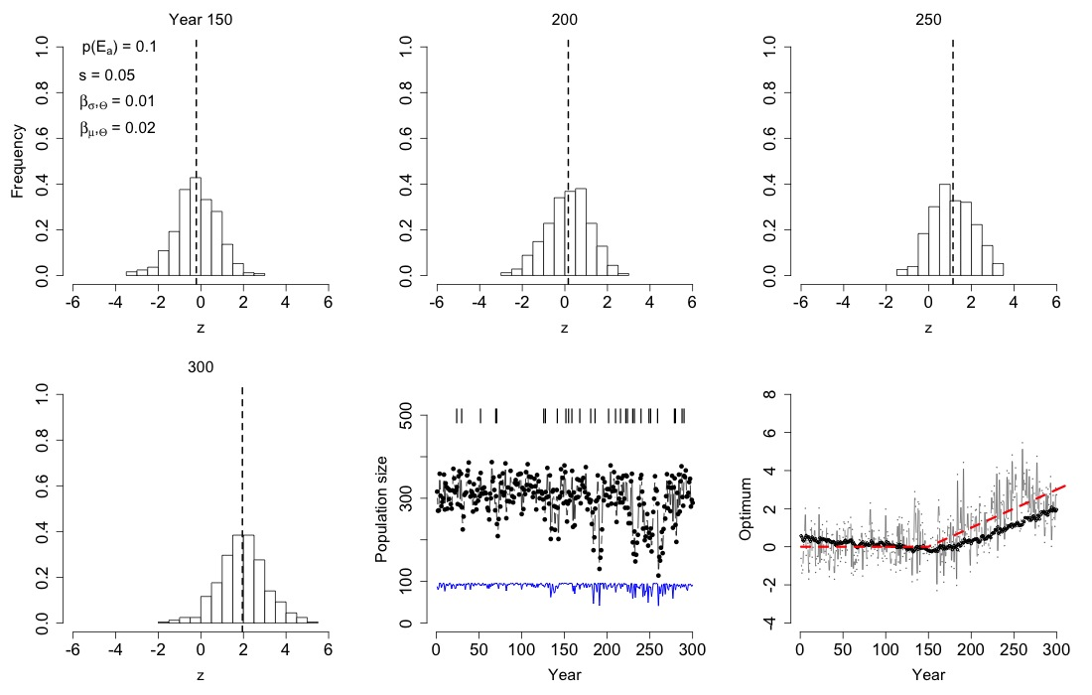
Figures ESM2. Lines of equal probability of extinction (number of populations going extinct divided by the number of replicates) in the mutation–selection plane for probability of point extremes p(E_{I,a}) = 5, 7.5, 10, 12.5 10⁻¹ and the four scenarios of increasing variability over simulation time of the optimum phenotype Θ (=0.5, 1, 1.5, 2 10⁻²) and two scenarios of increase in trend (bottom row: = 1 10⁻²; top row: = 2 10⁻²).
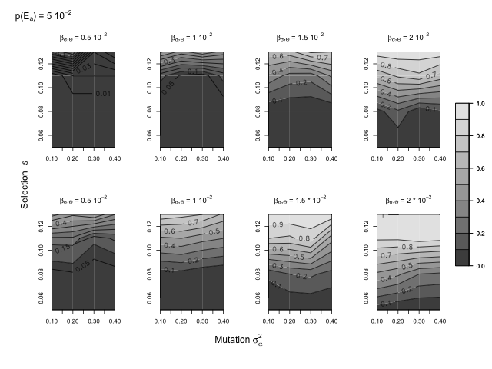

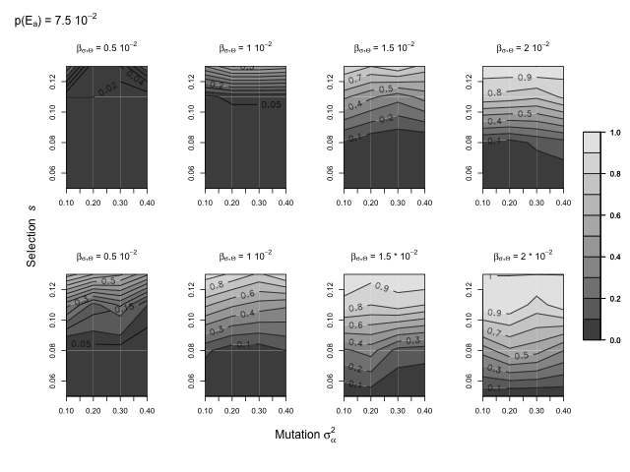

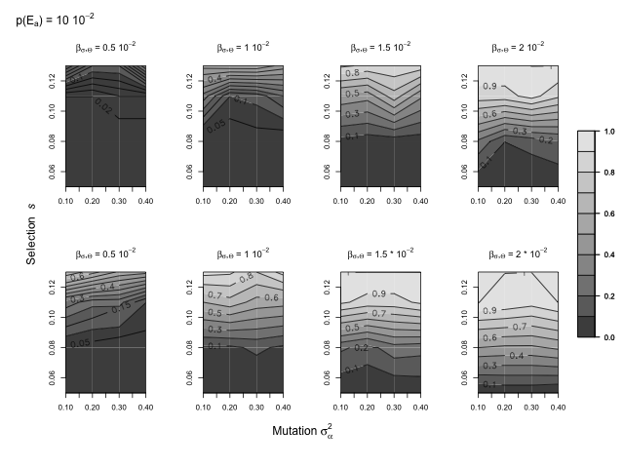

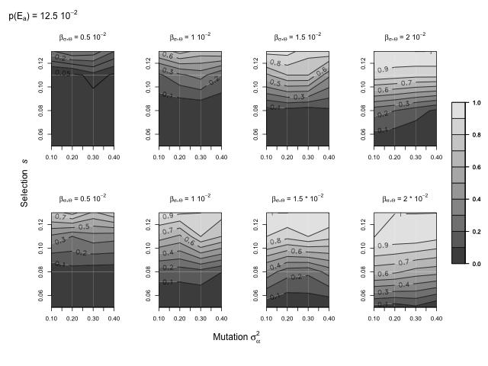

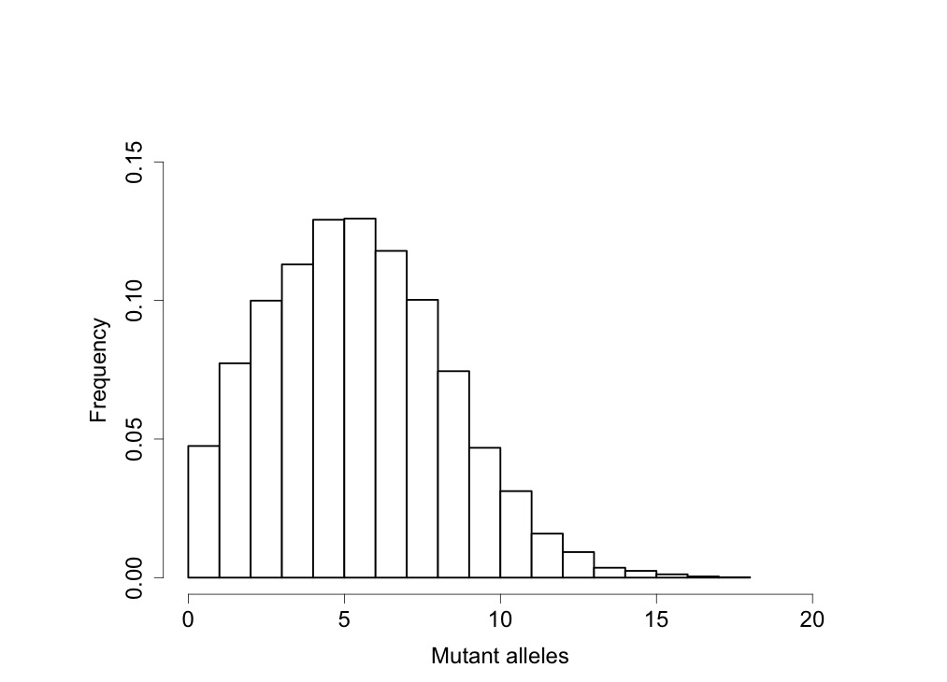

Figure ESM3. Distribution of number of mutant alleles found at the end of simulation time for populations that persisted up to the end of simulation time.
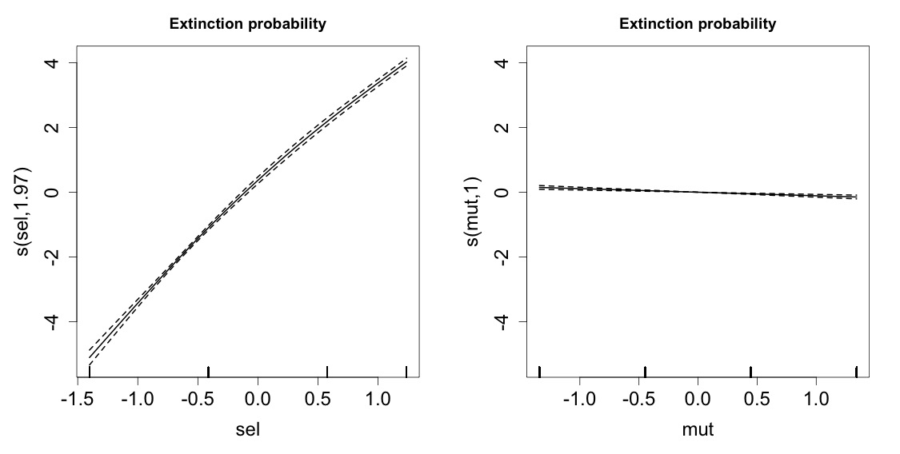

Figure ESM4. Smooth terms for extinction probability for selection strength (sel) and mutation amplitude (mut). Number within parentheses represent estimated degrees of freedom.
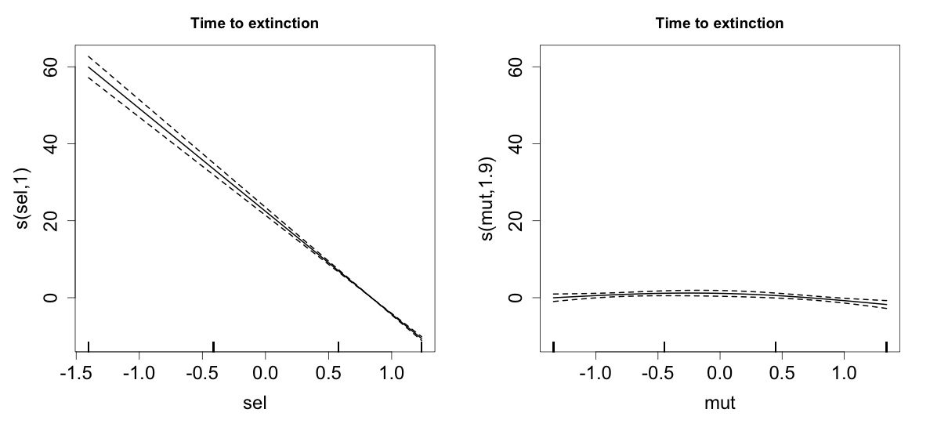

Figure ESM5. Smooth terms for time to extinction for selection strength (sel) and mutation amplitude (mut). Number within parentheses represent estimated degrees of freedom.
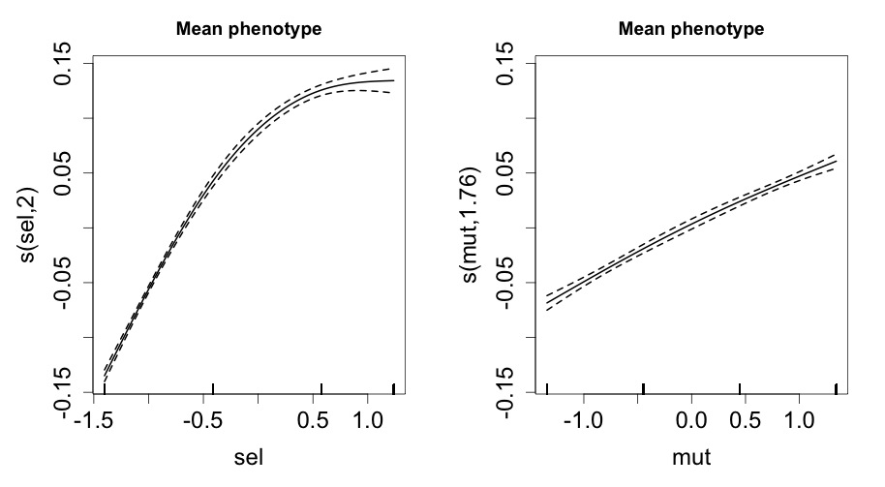

Figure ESM6. Smooth terms for mean phenotype at the end of simulation time for the populations that persisted for selection strength (sel) and mutation amplitude (mut). Number within parentheses represent estimated degrees of freedom.
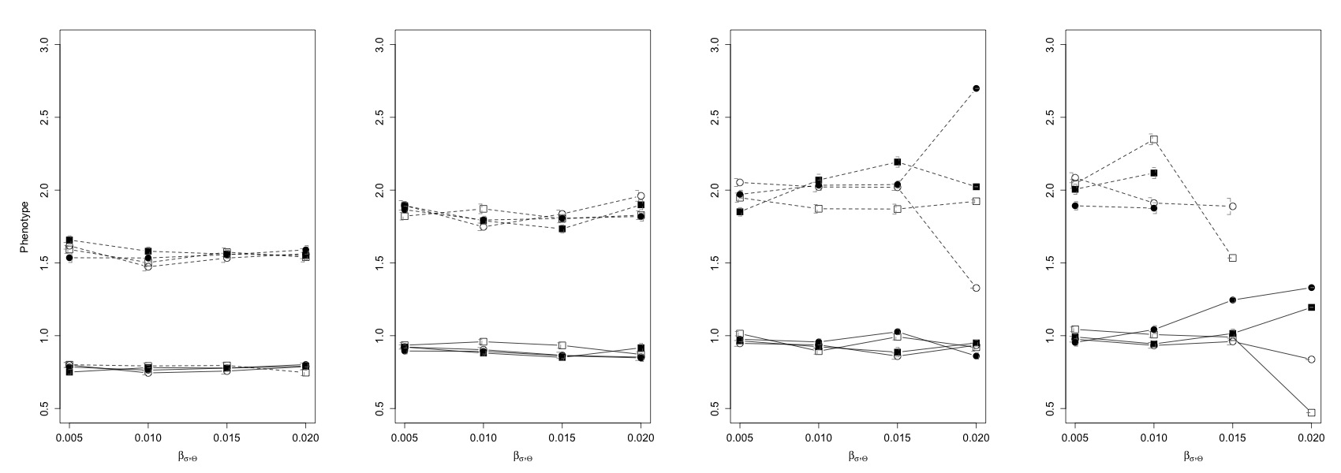

Figure ESM7. Mean in the last 10 years of simulation time of the mean value of the phenotype in the population with selection strength from left to right panel s = 5 10⁻² , 8 10⁻² 11 10⁻², 13 10⁻². . Symbols identify probability of point extreme events after climate change p(E_{I,a}) Open rectangle: p(E_{I,a}) = 5 10⁻²; open circle: 7.5 10⁻² ; solid rectangle: 10 10⁻²; solid circle: 12.5 10⁻² . Line type identifies magnitude of the directional trend of the continuous climate variable. Solid line: = 1 10⁻² ; dashed line: = 2 10⁻² . Vertical dashed segments describe standard deviations.
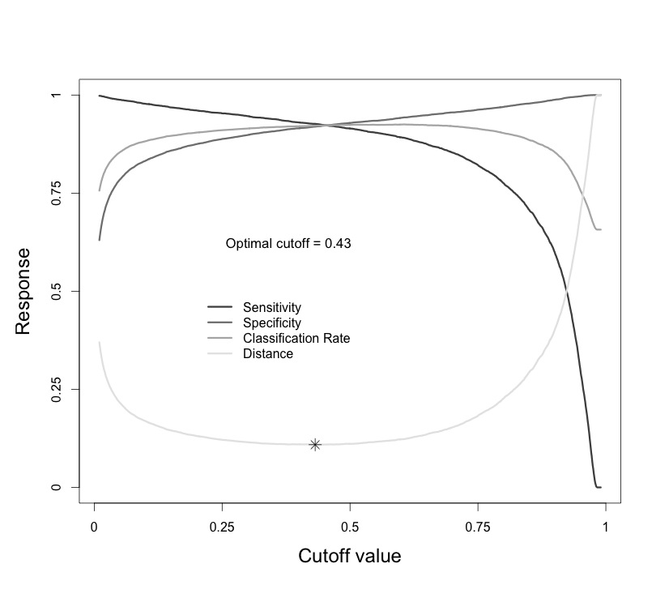

Figure ESM8. Sensitivity, specificity, classification rate (proportion of correct predictions) and distance () for the full GLM model (i.e., no mean population size in the “sampling window”) with extinction or persistence in the “extinction window” as response variable . The optimal cutoff identified by the star symbol corresponds to min(distance).
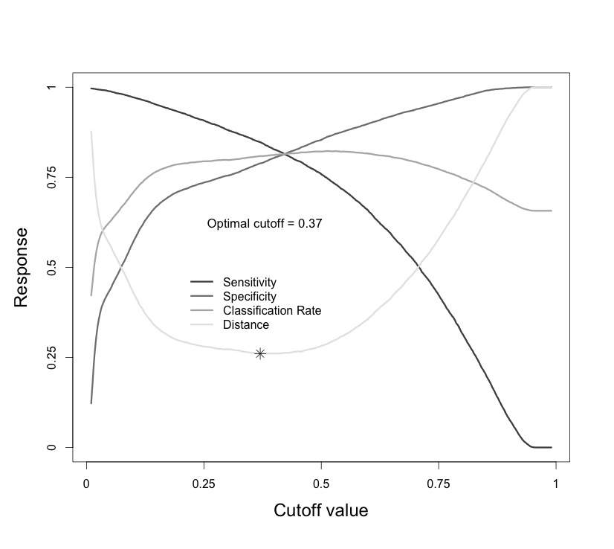

Figure ESM9. Sensitivity, specificity, classification rate (proportion of correct predictions) and distance () for the reduced GLM model (i.e., no mean population size in the “sampling window”) with extinction or persistence in the “extinction window” as response variable . The optimal cutoff identified by the star symbol corresponds to min(distance).
Figures ESM10. Examples of wrong predictions of the GLM (full) model that predicts extinction in a “extinction window” based on mean population size and additive genetic variance in a “sampling window” along with strength of selection and probability of point extreme. “Extinct” in the top left means that the population went extinct during simulation time (after extinction both population size and additive genetic variance go to 0). Red segments are point extremes, the blue line is additive genetic variance multiplied by 100, and the gray line and points represent population size. Between the two vertical dotted lines is the “sampling window” and between the dotted line and the dotted-dashed line lies the “extinction window”. In the plot are reported the prediction of the model (between 0 and 1, cutoff as in Figure ESM8), strength of selection, probability of occurrence of point extremes (Cat freq), mean population size and mean additive genetic variance in the “sampling window”.

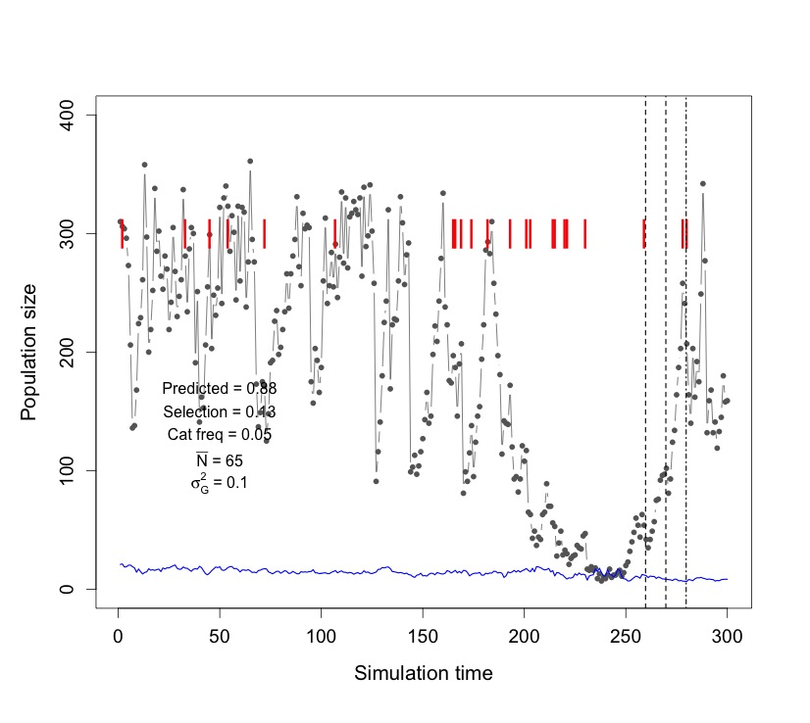

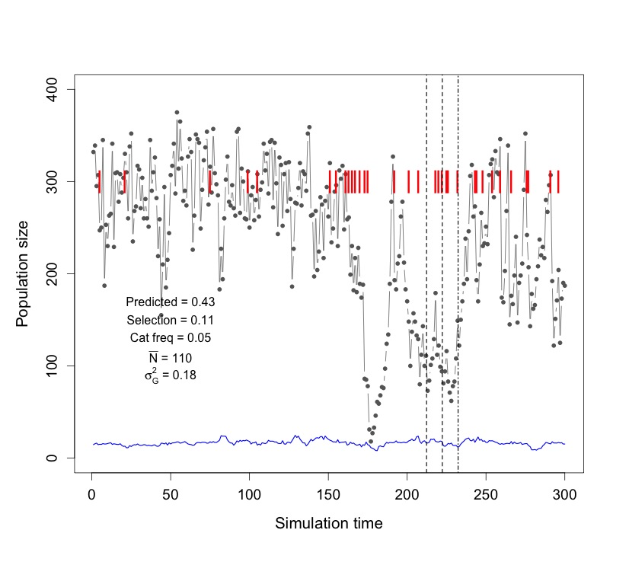

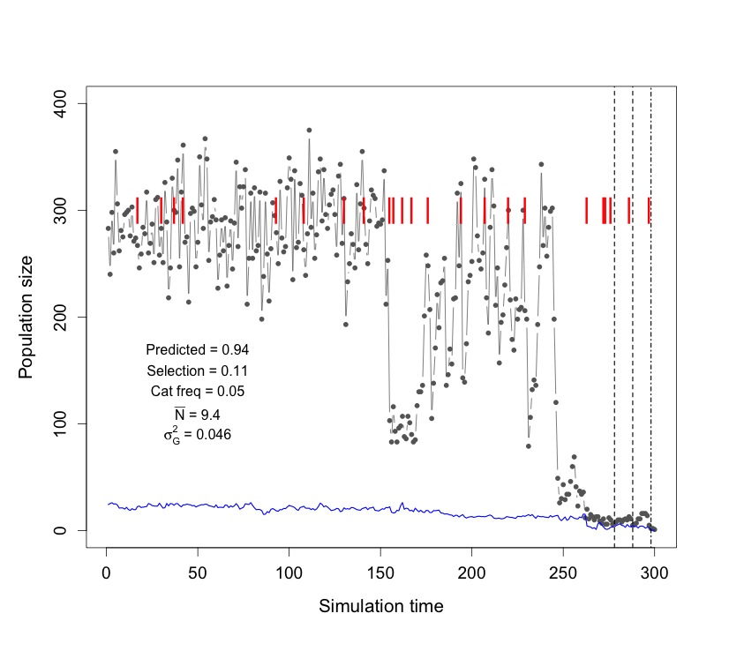

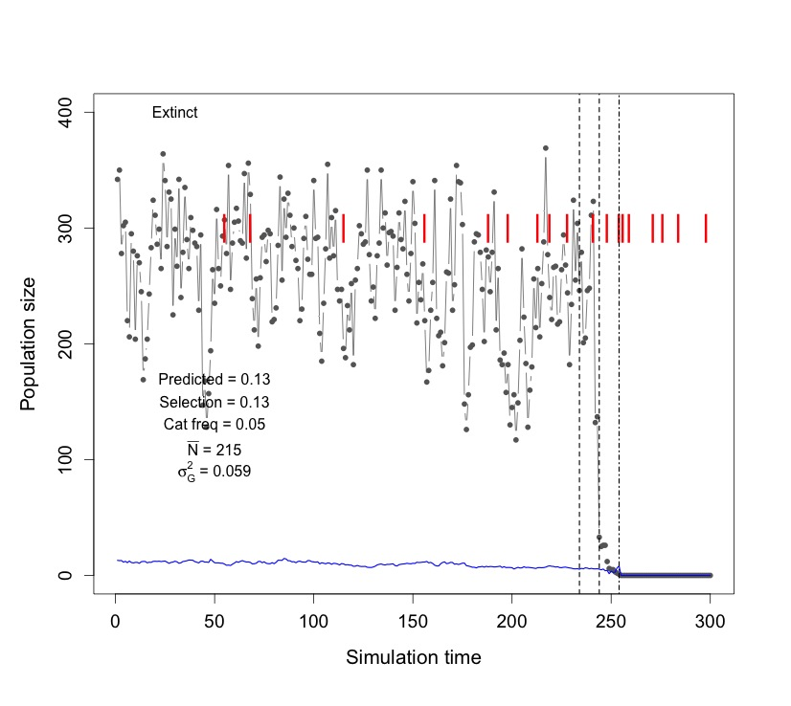
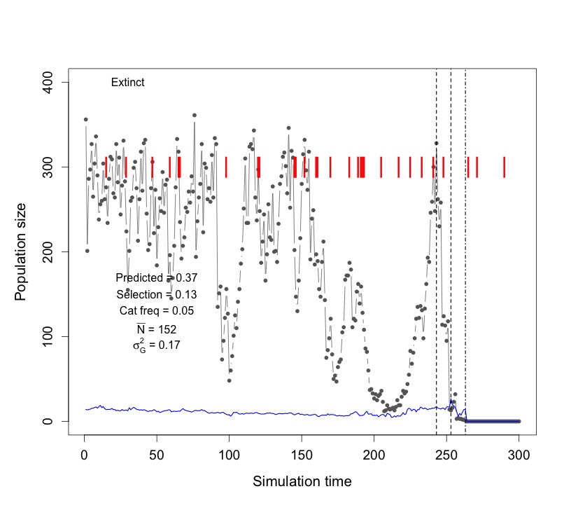
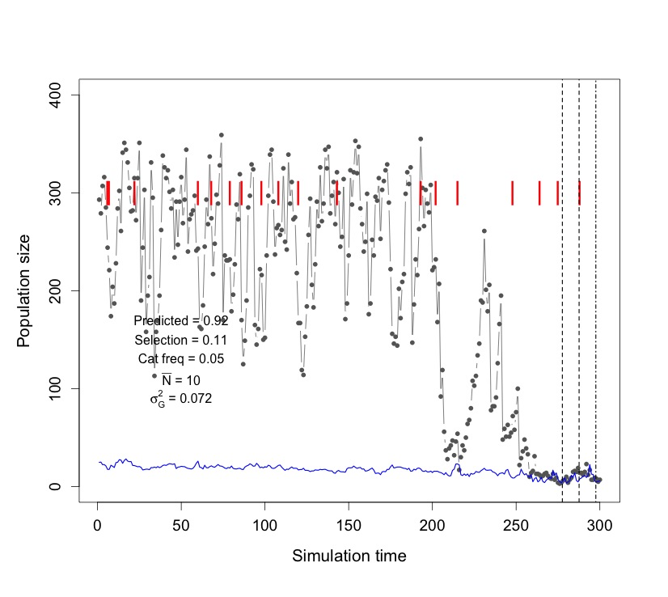

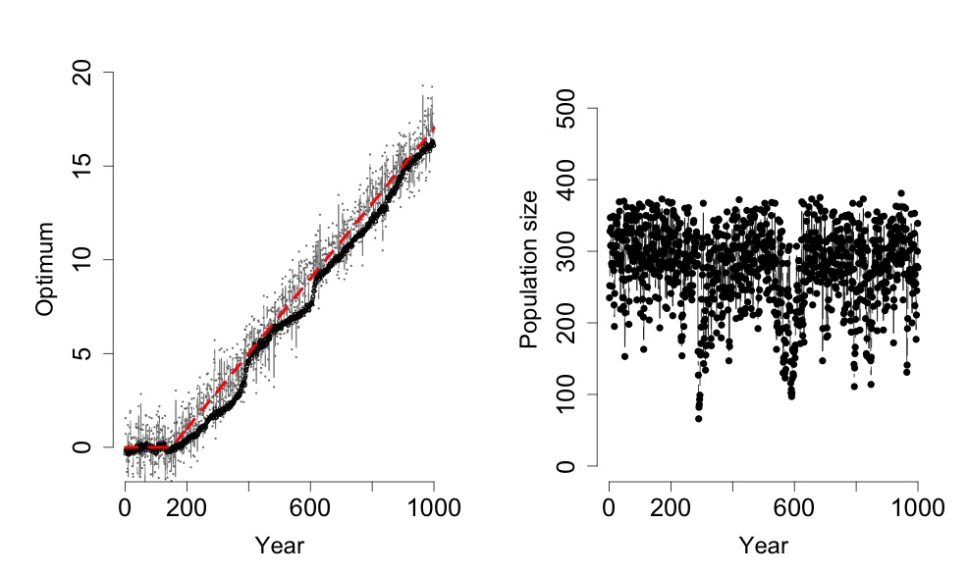

Figure ESM11. Left panel: Optimum (gray), mean of the distribution of the optimum (red line), and mean phenotype (black), with = 2 10⁻²,= 0 (no increase variability over time), and p(E_{I,a}) =0 . Right panel: population size over time.
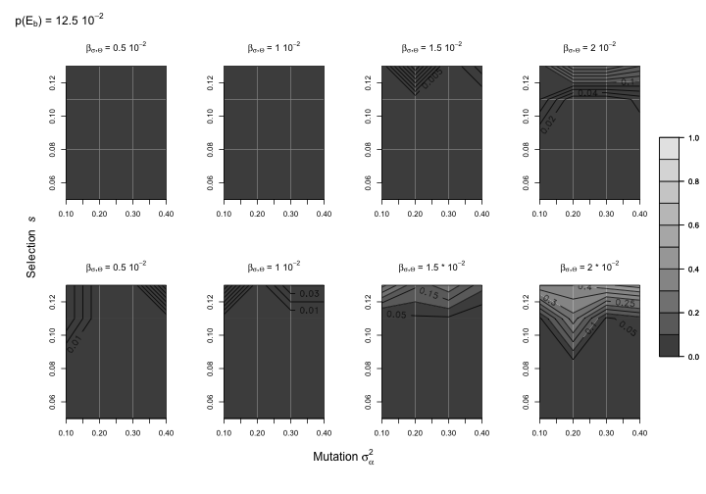
Figure ESM12. Lines of equal probability of extinction (number of populations going extinct divided by the number of replicates) in the mutation–selection plane with Poisson rate parameter for number of offspring produced by a mating pair λ_{ο} = 3 for probability of point extremes p(E_{I,a}) = 12.5 10⁻¹ and the four scenarios of increasing variability over simulation time of the optimum phenotype Θ (=0.5, 1, 1.5, 2 10⁻²) and two scenarios of increase in trend (bottom row: = 1 10⁻²; top row: = 2 10⁻²).

Figure ESM13. Partial R² (for OLSs) and Wald Χ² (for GLM) for predictors. a = time to extinction for the populations that went extinct (excluding the few extinctions that occurred before climate change, b = mean phenotype , c= additive genetic variance at the end of simulation time for the populations that survived, d = extinction(1)/persistence(0). The hierarchy defined by partial R² (for OLSs) and Wald Χ² (for GLM) is consistent with the regression parameters.
a
b
c
d
Figure ESM14. Frequency of replicates with different strength of selection that went extinct with 0 (white), 1 (gray), or 2 or more (black) point extremes in the five years before extinction.
Box ESM1. Further details on the model of population and genetic dynamics.
Simulations
The Monte Carlo simulation at a time t during the simulation proceeds as follows. I: (1) draw the optimum phenotype Θ(t) from Θ (t), (2) compute the annual survival probability of individuals by applying Eq. (2), and (3) determine the survival of individuals using Bernoulli trials. Then, I compute the total number of individuals alive N(t) and check the distribution of trait z (z(t)) in the population. A population is considered extinct if at any time during the simulation there are less than 2 individuals in the population. Then, (4) surviving individuals form mating pairs and produce a number of offspring randomly drawn from a Poisson distribution with intensity (i.e. expected value and variance) λ_{ο} equal to 2. I allow for full genetic recombination, which decreases linkage disequilibrium and tends to increase additive genetic variance (i.e. reduces the Bulmer effect, [1]). Offspring receive for the same locus one allele from each parent. Given a mutation (with probability n_{l} μ), the locus of the offspring at which it occurs is chosen randomly. Finally, (5) offspring are randomly introduced in the population from the pool produced by all the mating pairs until K is reached, and the remaining offspring die.

Choice of parameter values
I reduced parameter space by fixing K = 500, = 0, = 1, = 0, =1, = 0.2, p(E_{I,b}) = 0.05, = 0.3, and t_{inc} = 25 years. For the other parameter, I chose range of values that are both realistic for natural populations and instrumental for the main object of the study, e.g. investigate the consequences of extreme events on population dynamics, risk of extinction, and evolution of a quantitative trait. I performed simulations for combinations of selection strength s from 5 10⁻² (weak selection), to 13 10⁻² (strong selection) [2]. For the rate of increase in the mean of Θ (i.e. directional trend) I used= 1 10⁻² and 2 10⁻², leading to values of of 1.5 and 3 at the end of simulation time, respectively. Per generation increase in the mean of the climate variable corresponds to 1% and 2% of the phenotypic standard deviation at time t_{ch}. This rate of increase should allow the population in absence of variability to persist almost indefinitely [3,4], and thus extinctions should not be caused by the effects of the climate trend alone. I used rates of the increase of the standard deviation of Θ (i.e. climate variability)from 0.5 10⁻² to 2 10⁻² (leading to standard deviations of Θ from 1.125 to 1.5 from year 175 onwards, that is approximately from 12.5 to 50% greater than the phenotypic standard deviation at t = 150). According to [3], when the standard deviation of the distribution of the optimumreaches the same order of magnitude as the width of the fitness function, the population is at risk of going suddenly extinct, with little role played by genetics. Therefore, I chose values of that substantially increase the probability of climate extremes, but did not inevitably make the population go extinct. I used probabilities of occurrence of point extreme events p(E_{a}) from 5 10⁻² (no variation before and after climate change, corresponding to a recurrence interval of 20 years) to 12.5 10⁻² (i.e., recurrence interval is 8 years) with a step of 2.5 10⁻² (Table 1). I used a moderate mortality caused by point extremes (= 0.3) and moderate p(E_{a}), since with higher mortality induced by point extremes and higher probability of their occurrence the system will be largely driven by the point extremes, with no or little role of genetics. I used mutation amplitude σ²_{a} ranging from 0.1 to 0.4. This way the variance introduced by mutation per generation (mutational variance) at the population level is in the order of 10⁻³ to 10⁻² , as suggested by reviews of empirical data [5,6].
References
1. Bulmer, M. G. 1971 The effect of selection on genetic variability. Am. Nat. 105, 201–211.
2. Kingsolver, J. G., Hoekstra, H. E., Hoekstra, J. M., Berrigan, D., Vignieri, S. N., Hill, C. E., Hoang, A., Gibert, P. & Beerli, P. 2001 The strength of phenotypic selection in natural populations. Am. Nat. 157, 245–61. (doi:10.1086/319193)
3. Bürger, R. & Lynch, M. 1995 Evolution and extinction in a changing environment: a quantitative-genetic analysis. Evolution (N. Y). 49, 151–163.
4. Lynch, M. & Lande, R. 1993 Evolution and extinction in response to environmental change. In Biotic Interactions and Global Change (eds P. M. Kareiva J. G. Kingsolver & R. B. Huey), pp. 234–250. Sunderland, MA: Sinauer Associates.
5. Johnson, T. & Barton, N. 2005 Theoretical models of selection and mutation on quantitative traits. Philos. Trans. R. Soc. Lond. B. Biol. Sci. 360, 1411–25. (doi:10.1098/rstb.2005.1667)
6. Lynch, M. & Walsh, B. 1998 Genetic and analysis of quantitative traits. Sinauer.

Box ESM2. Details about computer code and simulations
The code, statistical analyses and figures were all developed/carried out/produced with R.
The following packages were used:
- MASS
- Rlab
- sampling
- rms
- mgcv
- parallel
Each simulation takes approximately 33 seconds on a iMac with 4 cores (2.8 GHz Intel Core i7) and 16 GB or RAM. Simulations were run using parallel computation (8 virtual cores). 25 600 simulations took approximately 48 hours. Since it is quite common that virtual cores stop functioning, an error correcting routine was developed in order to check at regular intervals if one or more cores stopped working. If that was the case, the cluster was automatically rebuilt and the missing replicated were simulated again.
The code is available upon request, while a synthesis of the results and of the code to generate mean figures and results is available on figshare: http://dx.doi.org/10.6084/m9.figshare.706347

The potential results coming from each replicate are saved as a list and include, among others (vector = v, scalar = s, matrix = m):
- extinct (1) or no (0) s
- alleles m. each line is an alleles and the alleles after row 100 are mutant present in the population at the end of the simulation
  - col 1 = value for the allele
  - col 2 = frequency of allele in the population at time 1
  - col 3 = freq at time 50
  - col 4 = freq at time 100
  - col 5 = freq at time 150
  - col 6 = at time 200
  - col 7 = at time 250
- addvar (additive genetic variance at each time step) v
- phenvar (phenotypic variance at each time step) v
- yearextinct s if == 299 the population persisted
- phenomean (mean of phenotype every simulation step pre-selection) v
- heteroz (vector of heterozygosities for each gene) v
- sdopt s increase in variability for the first 20 years after climate change
- meanopt s trend increase
- selstrength s strength of selection
- mu.mut s mutation rate
- mut.alfa s amplitude of mutation
- fitness.mean v mean fitness at each simulation time step (adults)
- fitness.variance v variance in fitness at each simulation step (adults)
- optimum v optimum at each simulation step
- w_gen_mean v mean of the phenotype of the offspring at each simulation step
- w_gen_var v variance of the phenotype of the offspring at each simulation step
- catastr.vett v (0) for catastrophe not occurring (1) catastrophe occurring
- popsize.pre v population size before selection and before that year catastrophe
- popsize.post v population size post selection

